Is It Possible to Reach Future 1.5 degree?

The phenomenon of climate change is not debateable anymore. It is real, as our earth’s temperature keep increasing by each year. The rise is caused by the massive amount of greenhouse gases (GHGs) are trapped on the atmosphere. Carbon dioxide (CO2), Methane (CH4), Nitrous Oxide (N2O) and Fluorinated gases (F-gases) are the 4 major gas of GHGs (Nunez, 2019)[[1]](https://www.nationalgeographic.com/environment/article/greenhouse-gases). The human activities are the main trigger of these gases being released to the atmosphere which eventually result in the temperature rise or global warming. In the long term, the global warming not only can bring the average surface warming, but also the extreme weather events, shifting wildlife populations and habitats, rising seas, and a range of other impacts. Out of the world GHGs emission, almost three-quarters are come from CO2, which make it as the primary greenhouse gas (Nunez, 2019)[[1]](https://www.nationalgeographic.com/environment/article/greenhouse-gases). In fact, almost every activity done by humans produce CO2, from burning fossil fuels for industry and transportation needs, clearing of forests for land use, and even we released CO2 from normal breathing. Actually, the trend on utilizing fossil fuels already started before the pre-industrialization (before 1750), but it is getting out of hand when came into the era of 20th and 21th century (European Union)[[2]](https://ec.europa.eu/clima/change/causes_en). Below is the full detail of the global CO2 emissions from energy-related sector from 1900 to 2020.

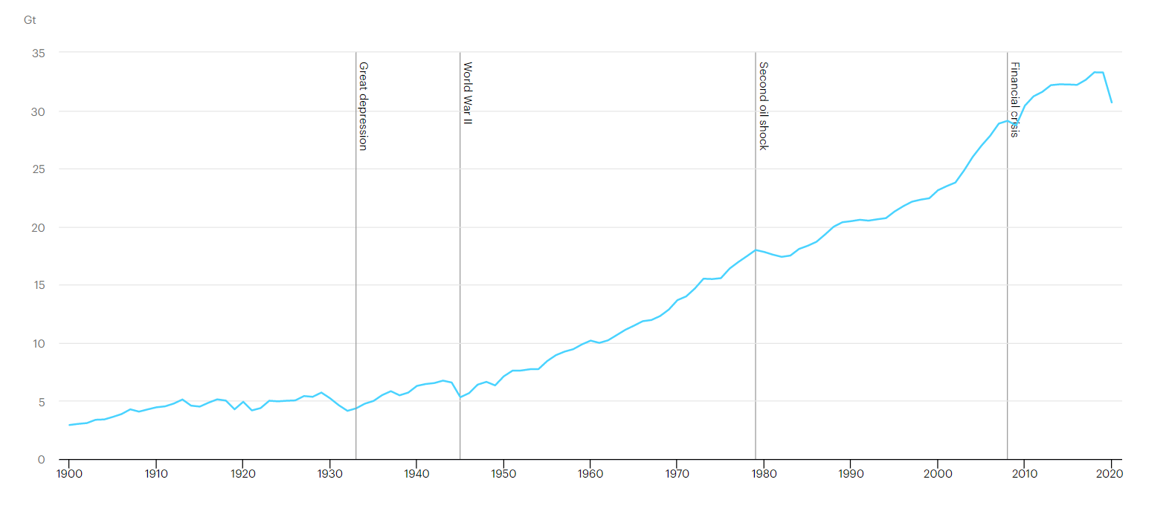

**Figure 1.** *Global energy-related CO2 emissions over 1900-2020 in Gigatons (Gt)* (Source: International Energy Agency-IEA, 2020)[[3]](https://www.iea.org/data-and-statistics/charts/global-energy-related-co2-emissions-1900-2020)

There are 4 different events presented on **Figure 1**. First, **The Great Depression (1929-1933)** of which had severed the world economic (Holahan, 2017)[[4]](https://ctmirror.org/category/ct-viewpoints/the-great-depression-and-the-great-warming/). The historical of stock market crash was occurred here. Reported by Holahan (2017)[[4]](https://ctmirror.org/category/ct-viewpoints/the-great-depression-and-the-great-warming/) that due to this crisis, people tend to conserve more energy by turning off lights, buying more fuel-efficient cars and putting solar panel on roofs. This is shown by a huge plunge on emission during the 1930. Second, **The World War II (1939-1945)** which had brought many adverse effects both environmentally and economically. During the war, it involved many non-eco-friendly technologies/transportation and destructive chemical substance, which resulted in emission increase until 1944. The war is ended in 1945, despite that, it is the start of the economy crisis. Simultaneously, there is increase in the mortality rate, hunger and the collapse of European industrial infrastructure (Kesternich et. al, 2014)[[5]](https://www.ncbi.nlm.nih.gov/pmc/articles/PMC4025972/). As the result, there was decrease in the human activities and emission which is shown by the drop on the graph near 1945.

Not long after that, the world economy and infrastructure started to recover. However, this has brought concern to our global emission as it increased rapidly until 1979. The third event was **The Second Oil Shock (1979)** due to the oil production shortage. The first oil shock was in 1973, the price was quadruple to almost $12 per barrel (Ketell, 2020)[[6]](https://www.britannica.com/topic/oil-crisis). However, the second oil shock almost triple to $34 per barrel. This price soared and production shortage led to low consumption and demand for crude oil as resource on that period (Gross, 2019)[[7]](https://www.brookings.edu/blog/order-from-chaos/2019/03/05/what-irans-1979-revolution-meant-for-us-and-global-oil-markets/). Resulting in a net loss of supply of about 4 to 5 percent. Therefore, between 1979 and mid-1980, there was significant fall for the global CO2 emission. After 1980, the price of the oil started to decline slowly, yet it still cost double than the pre-crisis. On the same time of the recovery, many alternatives such as nuclear power, gasoline and coal could be used to replace the oil demand as the primary resource (Toth and Rogner, 2006)[[8]](https://web.archive.org/web/20071203152254/http:/www.iaea.org/OurWork/ST/NE/Pess/assets/oil%2Bnp_toth%2Brogner0106.pdf). This helped the economy recovery as well as increase in total emission for the remaining 19th century (1986-1999). In the era of 21th century, it occurred **The Financial Crisis (2008)**. The financial bubbles, currency crisis and recession impacted the global economy during the crisis. Due to massive bankruptcy, many industries suffer to pay loan which resulted a decline in energy intensity within sector (Sadorsky, 2020)[[9]](https://www.mdpi.com/2071-1050/12/9/3867/pdf). However, the effect of the financial crisis on the global CO2 emission is not that significant. This is due to the expansion of energy demanding sectors in early stage (Sadorsky, 2020)[[9]](https://www.mdpi.com/2071-1050/12/9/3867/pdf), as the CO2 emissions keep increasing after 2010 (**Figure 1**).

In spite of all the differences which caused the global crisis and economy shock. We can see one similar trend which occurred during or post crisis, which is certain drop on the overall global CO2 emissions. However, if we analyse every of them, the drop was temporary. This is concerning, because the temporary decrease of CO2 emission means it is caused specifically due to the certain event, not the overall awareness. Unfortunately, until the 21th century, human still unaware the fact of more CO2 emission being trapped on the atmosphere. This can be seen on the **Figure 1** where the emissions still increased constantly until 2019.

If we look closely, there was sudden plunge after 2019. According to Le Quere et al. (2020)[[10]](https://www.nature.com/articles/s41558-020-0797-x), this major drop is due to the emergence of the Covid-19 as it is firstly identified in 30 December 2019 and declared a global pandemic by the World Health Organization on 11 March 2020 (Cucinotta and Vanelli, 2020)[[11]](https://pubmed.ncbi.nlm.nih.gov/32191675/). Some experts labelled this pandemic as “the biggest challenge for the world since World War II” (BBC, 2020)[[12]](https://www.bbc.com/news/world-52114829). IEA (2020)[[13]](https://www.iea.org/reports/global-energy-review-2020/global-energy-and-co2-emissions-in-2020) also commented that the decline is set to be almost twice as large as all previous declines since the end of World War II. As the pandemic become more uncontrollable, so to prevent the spread of Covid-19, many economic activities are being halt and government declared the lockdown policy. Travel and traffic restriction are being applied as well. This led to unprecedented decline for the demand in energy especially fossil fuels. IEA (2020)[[13]](https://www.iea.org/reports/global-energy-review-2020/global-energy-and-co2-emissions-in-2020)found that the global CO2 emissions were over 5% lower in Q1 2020 than in Q1 2019, mainly due to 8% decline in emissions from coal, 4.5% from oil and 2.3% from natural gas.

Since 2020 is still considered as the early stage of the pandemic. IEA (2020)[[13]](https://www.iea.org/reports/global-energy-review-2020/global-energy-and-co2-emissions-in-2020) is very optimist that by the end of the 2020, there will be nearly 8% decline in CO2 emissions compare to 2019. The decline is accounted for around 3 Gt which brought the CO2 to the level of 30.6 Gt by 2020. In fact, this would be the lowest level since 2010. This result also supported by Le Quere et al. (2020)[[10]](https://www.nature.com/articles/s41558-020-0797-x), which their paper proven similar outcome of 8% decrease on global 2020 emission by applying high end test 3. Moreover, if some restrictions remain worldwide in the future, it is projected for high estimate scenario with emission reduction of 7% (in between 3% to 13%). Whereas, if government remove the restriction in future, there will be small estimate scenario of 4% (in between 2% to 7%) CO2 reduction.

If we analyse closely, this pattern is similar to the previous 4 event patterns. The drop is considered as temporary, since there is no huge transition in the energy or transport sector in 2020 which can strongly support the major drop in our CO2 emission. As the only high potential reason is only due to the Covid-19 restriction. Like Le Quere et al. (2020)[[10]](https://www.nature.com/articles/s41558-020-0797-x)stated in their paper that most changes observed in 2020 are likely to be temporary as they do not reflect structural changes in the economic, transport or energy systems. However, in the long term, they claim still unpredictable due to the social trauma of confinement and associated changes could alter the future trajectory.

**But does major drop mean it is a good sign?**

This is true, the major drop is very favourable, but on the same time it alters the global economy, financial, trauma and it is just a temporary. By other means, this is not the scenario that we want to achieve. Since we are currently still on transition towards net zero emission future. Thus, we are looking for a long-term scenario. While, people ought to become aware of the global warming and together with the institutions and governments to achieve the future net zero emissions.

**Why it is important for people to be aware of the global warming?**

Above, we already introduced some direct effect of global warming towards our earth and society, not only that it is actually bring more of negative effect towards certain major industries like transportation, agriculture, manufacture and building. At worst, it could bring unexpected disaster which harm the society and wildlife. Hence, all of this will come back to us again.

**Then if not us, who will fight this?**

The world is in danger, many countries together pledge to tackle the global warming. One of the famous global climate change conference hosted by the United Nation (UN), namely Conference of the Parties (COP) is currently joined by 196 parties/countries (UNFCCC)[[14]](https://unfccc.int/process-and-meetings/the-paris-agreement/the-paris-agreement). There are two COPs that have established global agreements with specific emission reduction objectives:

* **COP 3 – The Kyoto Protocol (1997)**: The Kyoto Protocol aims to reduce average emission by 5% compared to 1990 levels over the five-year period of 2008–2012 (UNFCC)[[15]](https://unfccc.int/kyoto_protocol)
* **COP 21 – The Paris Agreement (2015)**: The Paris Agreement aims to limit global temperature rise to no more than 2°C but preferably to 1.5°C by 2100, through common but differentiated responsibilities of the Parties/Countries (UNFCCC)[[14]](https://unfccc.int/process-and-meetings/the-paris-agreement/the-paris-agreement).

Despite the Paris Agreement is meant for the long-term plan in 2100, yet it actually works on a 5- year cycle of increasingly ambitious climate action carried out by countries. This means each party need to submit their corresponding plan for climate action by 2020. For instance, not long from the Paris Agreement, in 2016 China published the 13th Five Year Plan which consist of 2016-2020 plan for emission reduction (China Government, 2016)[[16]](http://www.gov.cn/xinwen/2016-03/17/content_5054992.htm). Moreover, in 2021 they published the 14th Five Year Plan, as they declared to reach carbon peak in 2030 and carbon neutrality in 2060 (China Government, 2021)[[17]](http://www.gov.cn/xinwen/2021-03/13/content_5592681.htm). Similarly, many other parties like countries in European Union, United Kingdom, Japan and South Korea aim to achieve 2050 carbon neutrality. On the same time, to achieve such goal, they required to cut the global emission by 45% in 2030 compared with 2010 levels (Guterres, 2020)[[18]](https://www.un.org/sg/en/content/sg/articles/2020-12-11/carbon-neutrality-2050-the-world%E2%80%99s-most-urgent-mission). This year in 31st October 2021, the COP 26 will be held in Glasgow, Scotland. The COP 26 will be very decisive, as will mainly talk about our responsibility and plan to keep 1.5°C alive.

**But why should be 1.5°C?**

IPCC published a special report “Global Warming of 1.5°C” in 2018[[19]](https://www.ipcc.ch/sr15/). In 2017, they found that human-induced warming reached around 1°C (in between 0.8°C and 1.2°C) above the pre-industrial level (1850–1900), with increase by 0.2°C (in between 0.1°C and 0.3°C) per decade. It is true that past emission alone unlikely to raise further global average temperature. But it gives direct impact towards our earth such as sea level rise which might influence increase in further emission. With approximately 1°C as our current global temperature and the pledge to be net zero emission by 2050, they projected that it will likely less than 0.5°C over next two or three decades (IPCC, 2018)[[20]](https://www.ipcc.ch/site/assets/uploads/sites/2/2019/05/SR15_Chapter1_Low_Res.pdf).

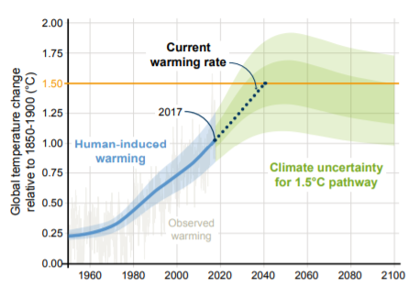

**Figure 2.** *Human-induced warming reached approximately 1°C above pre-industrial levels in 2017. At the present rate, global temperatures would reach 1.5°C around 2040. 2100 projection of 1.5°C pathways considering CO2 emissions reach zero by 2055.* (Source: IPCC, 2018)[[20]](https://www.ipcc.ch/site/assets/uploads/sites/2/2019/05/SR15_Chapter1_Low_Res.pdf)

Nevertheless, according to them this is a perfect scenario, where almost no fossil fuel powered engine and all anthropogenic emission is removed immediately. Thus, it is still unavoidable for warming greater than 1.5°C in future, whether it will occur depends on future rates of emission control and reduction.

Le Quere et al. (2018)[[21]](https://essd.copernicus.org/articles/10/2141/2018/essd-10-2141-2018.pdf) also projected CO2 mitigation curves for 1.5°C target. The **Figure 3** shows the amount of global CO2 emission need to be achieved in order to reach 1.5°C target. Each curve represents of different starting mitigation year from 2010 (red) to 2026 (blue).

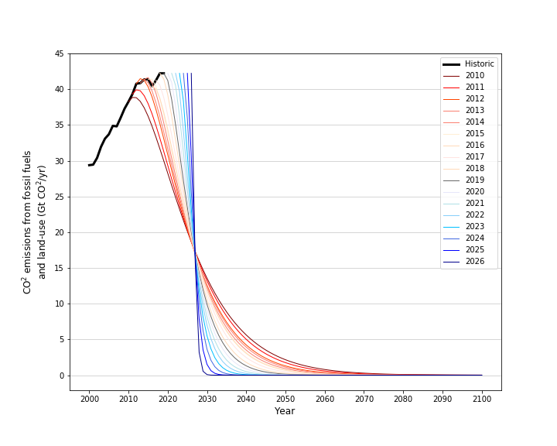

**1.5°C Target**

Starting Mitigation in 2010

Starting Mitigation in 2019

Starting Mitigation in 2026

**Figure 3.** *CO2 mitigation curves for 1.5°C target* (Source: Le Quere et al., 2018)[[21]](https://essd.copernicus.org/articles/10/2141/2018/essd-10-2141-2018.pdf)

If we start the mitigation early in 2010, the target will be more achievable. Since, the earlier mitigation (red) gives a better skewness for the curve. Better skewness is more attainable and it has better time frame management, as it is scattered across the years. However, the late mitigation such as starting 2026 will yield to vertical look alike curve. The late mitigation (blue) shows, in order to keep 1.5°C target by 2050, all the CO2 need to be mitigated to nearly zero by 2030. Realistically it is impossible to achieve this. Therefore, in alternative Le Quere et al. (2018) proposed the second scenario, which is the 2°C scenario.

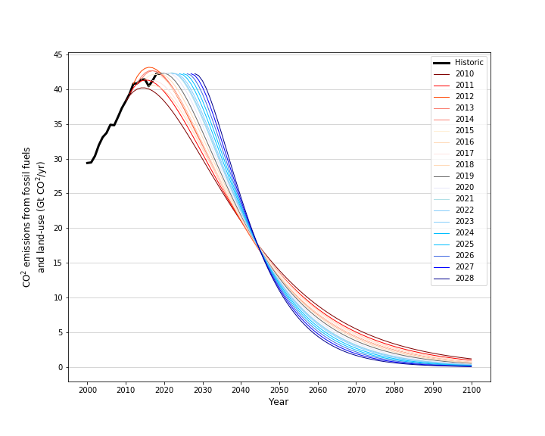

Starting Mitigation in 2010

Starting Mitigation in 2019

Starting Mitigation in 2028

**2°C Target**

**Figure 4.** *CO2 mitigation curves for 2°C target* (Source: Le Quere et al., 2018)[[21]](https://essd.copernicus.org/articles/10/2141/2018/essd-10-2141-2018.pdf)

The 2°C target is more attainable. Despite that, it does not mean we can delay the mitigation action until 2028. From the **Figure 3** and **Figure 4**, we can conclude that earlier mitigation starting time is more doable and achievable to reach the target.

**But why 2°C Scenario becomes the alternative?**

According to previous 2 projections, apparently to reach 1.5°C target will require relentless effort in either reduce the CO2 by replacing the fossil fuels with clean energy or remove the existing CO2 which have been trapped on the atmosphere. Not only that, if possible, this transition needs to be done as early as possible. This perfect scenario is surely not simple to be achieved, especially in the middle of pandemic, which affect the global healthcare and economy system. The 2°C scenario will be the next alternative. According to IPCC (2014)[[22]](https://web.archive.org/web/20151115020751/http:/www.ipcc.ch/pdf/assessment-report/ar5/syr/SYR_AR5_FINAL_full.pdf), 2°C will be the highest limit for future global warming, more than 2°C would have serious consequences, such as an increase in the number of extreme climate events. At COP 15 which held in Copenhagen 2009, they pledged to limit the global warming to 2°C by 2100 as well (UNFCCC)[[23]](https://unfccc.int/resource/docs/2009/cop15/eng/11a01.pdf). To reach this target, climate experts estimate that GHGs need to be reduced by 40-70% by 2050 and that carbon neutrality (zero emissions) needs to be reached by the end of the century at the latest (Thompson, 2014)[[24]](https://www.climatecentral.org/news/major-greenhouse-gas-reductions-needed-to-curtail-climate-change-ipcc-17300). If we analyse the projection of **Figure 4**, by 2050, there is approximately reduction of 60-70% from the initial amount of CO2 (from 38-42 Gt to 11-14 Gt).

If we are seriously aiming for future 1.5°C and 2°C target, it is essential not only for the government but also individuals and institutions to work on this together as well. As we discussed above, the government declared policies and feasible solution to tackle these issues. However, just policy will not help the world to achieve future zero carbon. Participation from institutions, organizations or enterprises are strongly needed as well. As they consist of entrepreneurs, experts and honorary people, therefore the solution, decision and action made will be impactful towards our targets. One China structural organisation namely Alxa Society of Entrepreneurs and Ecology (SEE) conservation has done many movements related to ecological protection, this includes wildlife conservation as well as environment preservation. Moreover, they also engage in social responsibility such as garbage sorting, nature education and more importantly carbon reduction. In December 2019 at COP 25, on the meeting session of “Enterprise Climate Action: Empowerment and Innovation” and “Low Carbon and Sustainable Life”, SEE was able to promote their “Green Chain Action” idea to the international level as carbon reduction and pollution treatment solution (SEE,2019)[[25]](http://conservation.en.see.org.cn/uploads/pdf/2019AnnualReportofSEEConservaion.pdf). One of the popular projects which supports the “Green Chain Action” is “Green Supply Chain” or green procurement, joined by total of 3669 real estate enterprises and China Urban Realty Association (CURA). This project period is from 2016-2019, it aims to reduce the pollution and carbon emission from the overall supply chains by promoting environmental rectification and improvement of upstream suppliers. They also promoted total of CNY 5.1 billion of procurement to meet environmental compliance requirements (SEE,2019)[[25]](http://conservation.en.see.org.cn/uploads/pdf/2019AnnualReportofSEEConservaion.pdf).

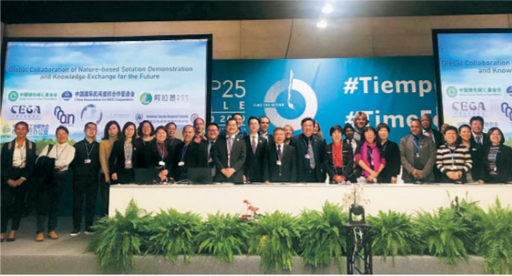

**Figure 5.** *Participants and SEE Delegation at COP 25* (Source: SEE,2019)[[25]](http://conservation.en.see.org.cn/uploads/pdf/2019AnnualReportofSEEConservaion.pdf)

Individuals can also contribute towards future low carbon. For example, actions on reducing waste, consume more of organic and low carbon labelled products, garbage sorting, help and promote the waste upcycling or recycling, and tree planting. Moreover, as we have entered the era of digitalisation in the 21st century, many problems can be solved through electronic devices. Similarly, tree planting also can be done electronically. In China, Alipay released afforestation program called “Ant Forest”. This is green low-carbon charity project, which aims to encourage the general public to choose green lifestyles (SINA, 2021)[[26]](https://finance.sina.com.cn/tech/2021-03-10/doc-ikkntiak7275695.shtml). Each time a user performs a lower-carbon activity, such as paying a utility bill online, cycling to work, paying public transportation and other low-carbon emission reduction activities, they are rewarded with "green energy points". This green energy points will help to grow the virtual tree and for every virtual tree grown, Ant Forest donates and plants a real one. According to the SINA (2021)[[26]](https://finance.sina.com.cn/tech/2021-03-10/doc-ikkntiak7275695.shtml), The Research Center for Ecological Environment of the Chinese Academy of Sciences and the World Conservation Union IUCN jointly showed that since 2016, they estimated the total production value of the ant forest ecosystem is CNY 11.306 billion, this also includes more than 223 million real trees that have been planted.

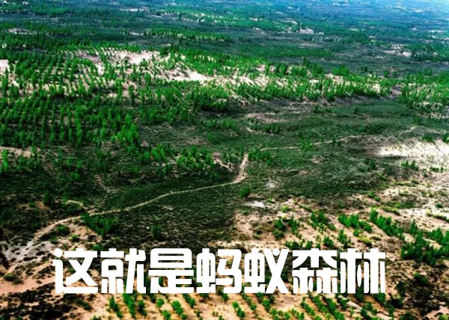

**Figure 6.** *The Ant Forest* (Source: IOTFen, 2017)[[27]](https://www.iotfen.com/566.html)

Therefore, every little effort given will contribute towards future 1.5°C or 2°C, no matter if it is come from a big institution, small organisation or individuals. Below, Ritchie and Roser (2021) shows the full projection of different warming scenarios and estimation of the GHG (in Gt).

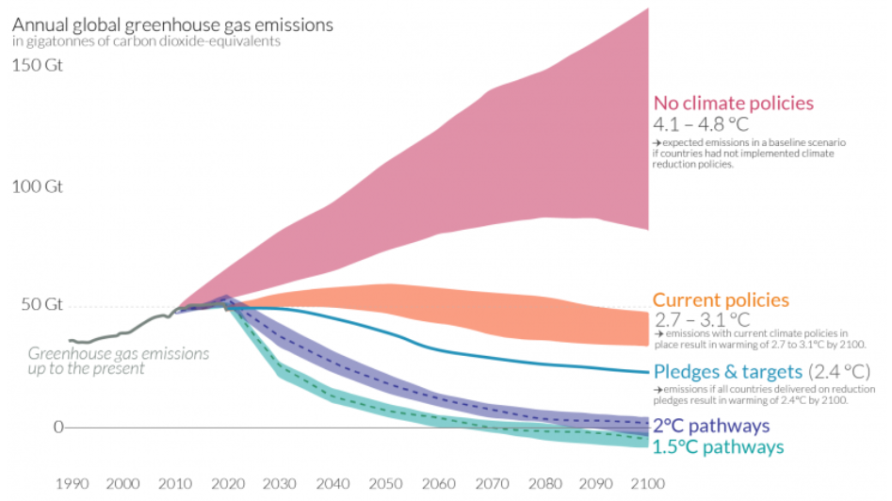

**Figure 7.** *Global GHG Emissions and Warming Scenarios* (Source: Ritchie and Roser, 2021)[[28]](https://ourworldindata.org/co2-and-other-greenhouse-gas-emissions#how-have-global-co2-emissions-changed-over-time)

The **Figure 7** shows with no implementation of the climate reduction policies and no actions being taken, the global temperature will experience 4.1°C to 4.8°C increase by year 2100, and the total GHG emission will be at least 100 Gt being trapped on the atmosphere or at worst case it can reach up to more than 150 Gt. If our current policies continued and we are going to reduce the emissions based on it, this will result in 2.7°C to 3.1°C increase by year 2100. In addition, if all countries are able to reach their reduction targets or pledges, this will be an even further improvement, with only 2.4°C increase by year 2100. With only current policies, we only can achieve 2.4°C increase as the lowest. This is very concerning, since the IPCC (2014)[[22]](https://web.archive.org/web/20151115020751/http:/www.ipcc.ch/pdf/assessment-report/ar5/syr/SYR_AR5_FINAL_full.pdf) stated that more than 2°C would have serious consequences to the future global climate change. Therefore, the Paris Agreement laid out both 1.5°C or 2°C pathways (UNFCCC)[[14]](https://unfccc.int/process-and-meetings/the-paris-agreement/the-paris-agreement). However, according to Ritchie and Roser (2021)[[28]](https://ourworldindata.org/co2-and-other-greenhouse-gas-emissions#how-have-global-co2-emissions-changed-over-time) that for both pathways, we are clearly far-off track. This has been supported by the IPCC special report on 1.5°C (IPCC, 2018)[[20]](https://www.ipcc.ch/site/assets/uploads/sites/2/2019/05/SR15_Chapter1_Low_Res.pdf) which to limit global average warming to 1.5°C, all anthropogenic emission must be removed immediately. Le Quere et al. (2018)[[21]](https://essd.copernicus.org/articles/10/2141/2018/essd-10-2141-2018.pdf) also mapped out the projections for both 1.5°C and 2°C scenarios. They show urgent and rapid emission reduction is needed, and the longer we delay a peak in emissions, the more drastic these reductions would need to be.

Relatively, we are making slow progress without any climate policies, but even with the policies, there is still far rates of progress to reach the international targets. We obviously are on transition, but it is currently too slow. Hence, large-scale acceleration of efforts across the world is a must. This includes technology scales and improvement, education and awareness, as well as climate action. Nowadays, the Carbon Removal Technology is discussed frequently. It introduces the concept of Carbon Capture, Utilization and Storage (CCUS) which has been implemented lately in order to reach the global carbon neutrality or even carbon negative. The Direct Air Capture (DAC) is one of many technologies which is able to remove the existing carbon on the atmosphere. However, it is considered expensive, since it costs around $250 to $600 per tonne in 2021, but they are confident that through supportive policies and market development, the cost could fall to around $150 to $200 per tonne over next 5-10 years (Lebling et al., 2021)[[29]](https://www.wri.org/insights/direct-air-capture-resource-considerations-and-costs-carbon-removal). On the same time, the large scale of replacement on fossil fuels energy with clean and renewable energy are required as well. Another effort is through education, this could be from institute, internet and conferences. It is important, since the term “global warming” is not widely known, as well as the drawback towards our earth. Alternatively, awareness sharing could be an education platform as well, which happen often nowadays through striking. Furthermore, a conference & exhibitions could be another better platform to learn. In exhibition, we can see many interesting cutting-edge technologies which could help our earth to reach zero carbon. During the conference, we can understand the perspective of many experts, government and high-level position person from different background and industry towards our future zero-carbon. Impact X, as a global conference platform are going to hold a “2021 Impact X Haikou Climate Growth Summit” in April 2022. Joined by government, head of international organization, industry experts, C-level executives, investor and founder of start-up company to discuss the carbon neutral roadmap. Not only that, there will be competition for the start-ups to showcase their technologies and innovations. For every field industry (Agriculture, Built Environment, Energy, Industry & Manufacture and Transportation), we are going to choose a winner and each winner will able to present its technology on the conference day. Beside education, in conference we can build connection and exchange ideas with each other as well. Once we obtained the education, the next step will be the climate action. This has been stated above that the government, institutions and individuals can contribute towards our future low carbon target in different ways.

**Is it possible to reach future 1.5°C or 2°C?**

The future is uncertain, but this does not mean that we cannot change it. The policies and pledges have been made, but seemingly we are stuck with the policy. There are still many opportunities for us to improve significantly, for instance DAC which still have huge scalable opportunity and replace the fossil fuels with clean energy. Pathways and scenarios have been mapped out, so it just depends on the humanity. Both 1.5°C and 2°C are possible to achieve, however in reality the 2°C is more favourable as has been mapped out on **Figure 3**, the 1.5°C need to be done urgently or it will not happen. With current situation and research done, I believe 2°C is very attainable if we continue to improve in the technology and awareness in the future.

**Reference:**

[1] Nunez, C. (2019) *Carbon dioxide levels are at a record high. Here's what you need to know*. National Geographic [Online]. Available at: <https://www.nationalgeographic.com/environment/article/greenhouse-gases> (Accessed: 10 August 2021)

[2] European Union. *Causes of climate change* [Online]. Available at: <https://ec.europa.eu/clima/change/causes_en> (Accessed: 10 August 2021)

[3] IEA (2020) *Global energy-related CO2 emissions, 1900-2020* [Online]. Available at: <https://www.iea.org/data-and-statistics/charts/global-energy-related-co2-emissions-1900-2020> (Accessed: 10 August 2021)

[4] Holahan, D. (2017) *The Great Depression and the Great Warming*. The CT Mirror[Online]. Available at: <https://ctmirror.org/category/ct-viewpoints/the-great-depression-and-the-great-warming/> (Accessed: 10 August 2021)

[5] Kesternich, I. et al. (2014) *The Effects of World War II on Economic and Health Outcomes across Europe*. PMC, 96(1), p. 103–118[Online]. Available at: <https://www.ncbi.nlm.nih.gov/pmc/articles/PMC4025972/> (Accessed: 10 August 2021)

[6] Kettell, S. (2020) *Oil crisis*. Britannica [Online]. Available at: <https://www.britannica.com/topic/oil-crisis> (Accessed: 10 August 2021)

[7] Gross, S. (2019) *What Iran’s 1979 revolution meant for US and global oil markets*. The Brookings Institution [Online]. Available at: <https://www.brookings.edu/blog/order-from-chaos/2019/03/05/what-irans-1979-revolution-meant-for-us-and-global-oil-markets/> (Accessed: 10 August 2021)

[8] Toth, F. L. and Rogner, H. (2006) *Oil and nuclear power: Past, present, and future*. Energy Economics, 28(2006), p. 1-25[Online]. Available at: <https://web.archive.org/web/20071203152254/http://www.iaea.org/OurWork/ST/NE/Pess/assets/oil%2Bnp_toth%2Brogner0106.pdf> (Accessed: 10 August 2021)

[9] Sadorsky, P. (2020) *Energy Related CO2 Emissions before and after the*

*Financial Crisis*. MDPI, Sustainability 2020, 12(3867), p. 1-22 [Online]. Available at: <https://www.mdpi.com/2071-1050/12/9/3867/pdf> (Accessed: 10 August 2021)

[10] Le Quere, C. et al. (2020) *Temporary reduction in daily global CO2 emissions during the COVID-19 forced confinement*. Nature Climate Change, 10, p. 647-653 [Online]. Available at: <https://www.nature.com/articles/s41558-020-0797-x> (Accessed: 11 August 2021)

[11] Cucinotta, D. and Vanelli, M. (2020) *WHO Declares COVID-19 a Pandemic*. PMC, 91(1), p. 157-160[Online]. Available at: <https://pubmed.ncbi.nlm.nih.gov/32191675/> (Accessed: 11 August 2021)

[12] BBC (2020) *Coronavirus: Greatest test since World War Two, says UN chief* [Online]. Available at: <https://www.bbc.com/news/world-52114829> (Accessed: 11 August 2021)

[13] IEA (2020) *Global energy and CO2 emissions in 2020* [Online]. Available at: <https://www.iea.org/reports/global-energy-review-2020/global-energy-and-co2-emissions-in-2020> (Accessed: 11 August 2021)

[14] UNFCCC. *The Paris Agreement* [Online]. Available at: <https://unfccc.int/process-and-meetings/the-paris-agreement/the-paris-agreement> (Accessed: 11 August 2021)

[15] UNFCCC. *What is the Kyoto Protocol?* [Online]. Available at: <https://unfccc.int/kyoto_protocol> (Accessed: 11 August 2021)

[16] China Government (2016) *中华人民共和国国民经济和社会发展*

*第十三个五年规划纲要* [Online]. Available at: <http://www.gov.cn/xinwen/2016-03/17/content_5054992.htm> (Accessed: 12 August 2021)

[17] China Government (2021) *中华人民共和国国民经济和社会发展第十四个五年规划和2035年远景目标纲要* [Online]. Available at: <http://www.gov.cn/xinwen/2021-03/13/content_5592681.htm> (Accessed: 12 August 2021)

[18] Guterres, A. (2020) *Carbon neutrality by 2050: the world’s most urgent mission*. United Nation Secretary-General. [Online]. Available at: <https://www.un.org/sg/en/content/sg/articles/2020-12-11/carbon-neutrality-2050-the-world%E2%80%99s-most-urgent-mission> (Accessed: 12 August 2021)

[19] IPCC (2018) *Global Warming of 1.5°C*. [Online]. Available at: <https://www.ipcc.ch/sr15/> (Accessed: 12 August 2021)

[20] IPCC (2018) *Global Warming of 1.5°C*. Chapter 1 [Online]. Available at: <https://www.ipcc.ch/site/assets/uploads/sites/2/2019/05/SR15_Chapter1_Low_Res.pdf> (Accessed: 12 August 2021)

[21] Le Quere, C. et al. (2018) *Global Carbon Budget 2018*. Earth System Science Data, 10, p. 2141-2194[Online]. Available at: <https://essd.copernicus.org/articles/10/2141/2018/essd-10-2141-2018.pdf> (Accessed: 12 August 2021)

[22] IPCC (2014) *Climate Change 2014: Synthesis Report* [Online]. Available at: <https://web.archive.org/web/20151115020751/http://www.ipcc.ch/pdf/assessment-report/ar5/syr/SYR_AR5_FINAL_full.pdf> (Accessed: 13 August 2021)

[23] UNFCCC (2010) *Report of the Conference of the Parties on its fifteenth session, held in Copenhagen from 7 to 19 December 2009* [Online]. Available at: <https://unfccc.int/resource/docs/2009/cop15/eng/11a01.pdf> (Accessed: 13 August 2021)

[24] Thompson, A. (2014) *Major Greenhouse Gas Reductions Needed by 2050: IPCC*. Climate Central[Online]. Available at: <https://www.climatecentral.org/news/major-greenhouse-gas-reductions-needed-to-curtail-climate-change-ipcc-17300> (Accessed: 13 August 2021)

[25] SEE (2019) *2019 ANNUAL REPORT of SEE Conservation* [Online]. Available at: <http://conservation.en.see.org.cn/uploads/pdf/2019AnnualReportofSEEConservaion.pdf> (Accessed: 13 August 2021)

[26] SINA (2021) *中科院发布蚂蚁森林GEP核算报告 5亿中国人种出超百亿生态效益*[Online]. Available at: <https://finance.sina.com.cn/tech/2021-03-10/doc-ikkntiak7275695.shtml> (Accessed: 13 August 2021)

[27] IOTFen (2017) *What the ant forest looks like when it grows up: The Wizard of Oz!* [Online]. Available at: <https://www.iotfen.com/566.html> (Accessed: 13 August 2021)

[28] Ritchie, H. and Roser, M. (2020) *CO₂ and Greenhouse Gas Emissions*. Our World in Data [Online]. Available at: <https://ourworldindata.org/co2-and-other-greenhouse-gas-emissions#how-have-global-co2-emissions-changed-over-time> (Accessed: 13 August 2021)

[29] Lebling, K. et al. (2021) *Direct Air Capture: Resource Considerations and Costs for Carbon Removal*. WRI [Online]. Available at: <https://www.wri.org/insights/direct-air-capture-resource-considerations-and-costs-carbon-removal> (Accessed: 12 August 2021)